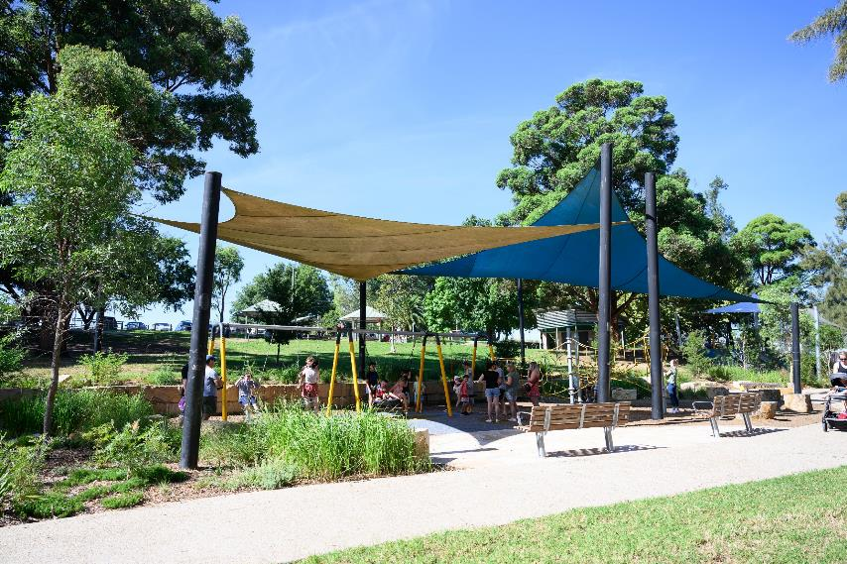

A Social Story for
Tench Reserve Playground

Tench Reserve is for families and friends of all ages and abilities. You can play, relax and connect with others.

A Note to Parents and Carers
Social stories are a communication tool to assist individuals and families when visiting new and busy environments.
Using this social story prior to and during your visit can help gain familiarity with types of play and amenities available at Tench Reserve.

Location
Tench Avenue, Jamisontown
Opposite East Bank restaurant precinct
Parking and Accessibility
Roadside parking on Tench Avenue
Nearest Bus Stop: ID 2750177
Developed in collaboration with
Autism Community Network and reviewed by local families

Table of Contents
- Location Overview
- Entrance Ramp
- Picnic Tables
- Toilets and MLAK Accessible Toilet
- Slides and Rock Climbing
- Trampolines
- Water Play Area
- Large Climbing Equipment
- Rope Climbing
- Benches
- Swing and Accessible Swing
- Departure

What to Bring
- Hat and sunscreen
- Water bottle and snacks

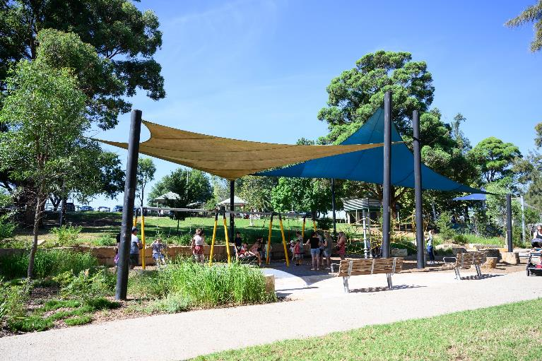

I am visiting Tench Reserve.

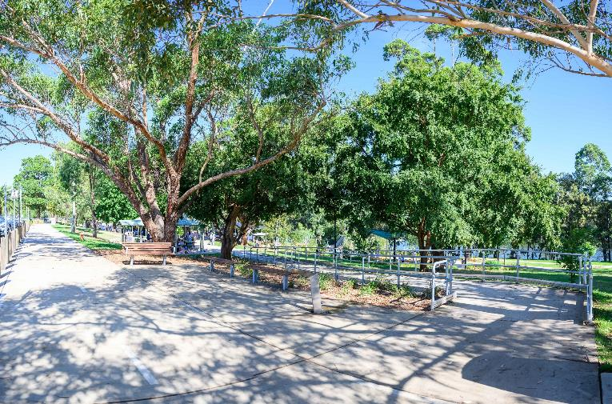

I arrive at the playspace from the top of a hill.

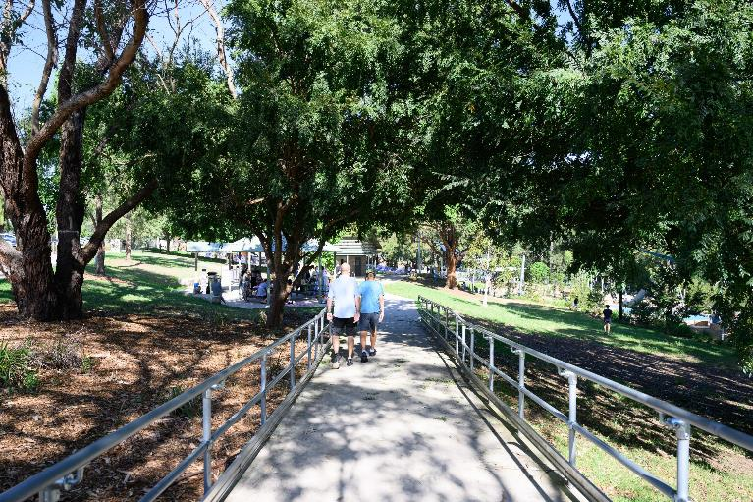

I can enter through an accessible ramp.

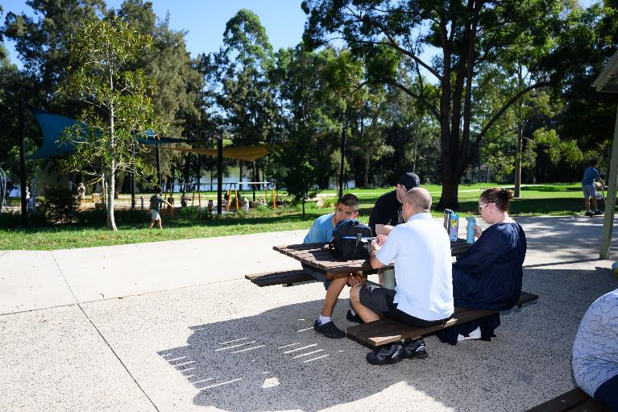

And I can have a snack on the picnic tables.

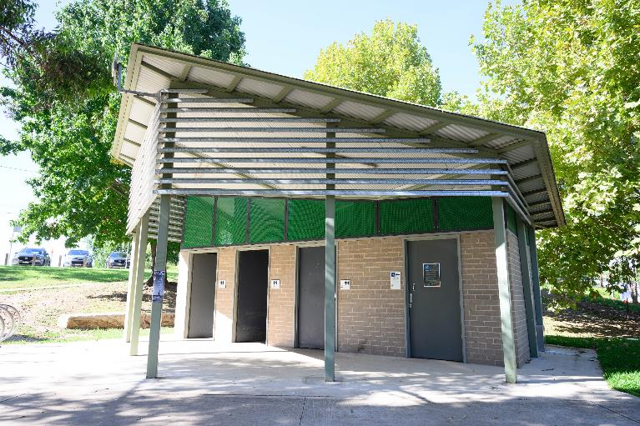

I can use the toilets next to the picnic area.

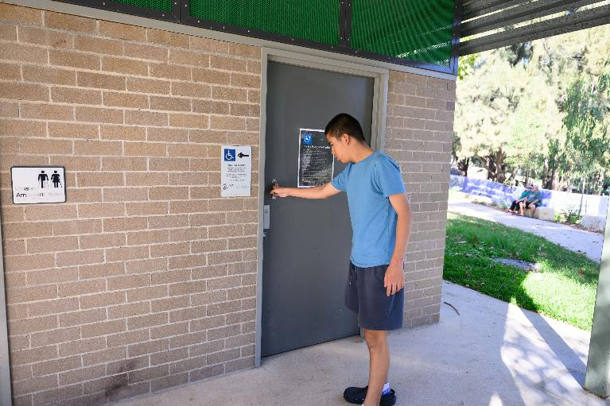

And there is also a MLAK accessible toilet.

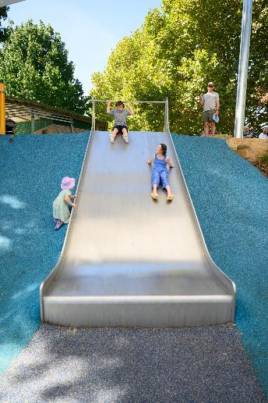

I can play on the big metal slide.

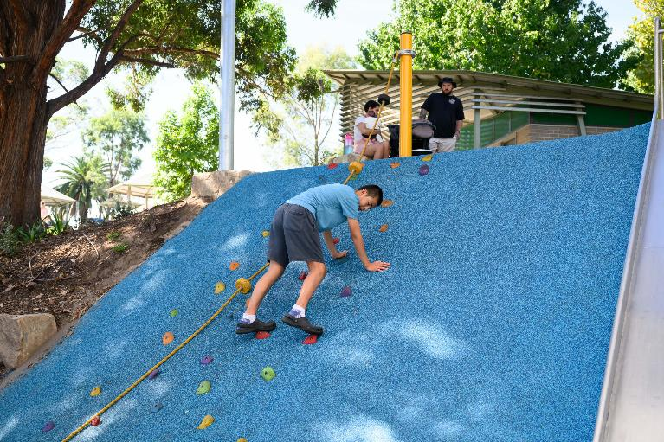

And I can try some rock climbing.

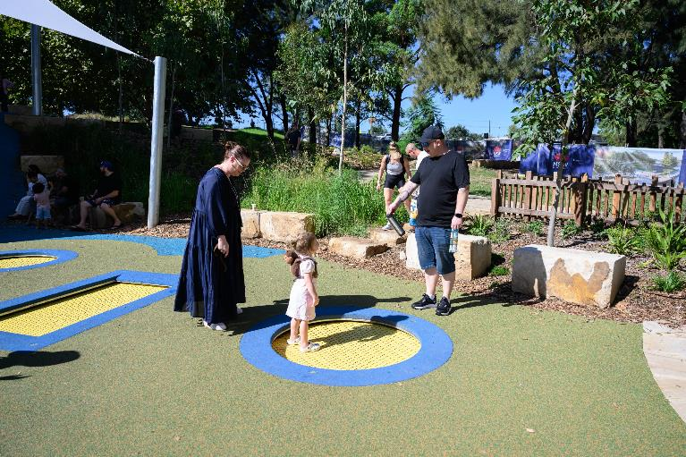

I can jump on the in-ground trampolines.

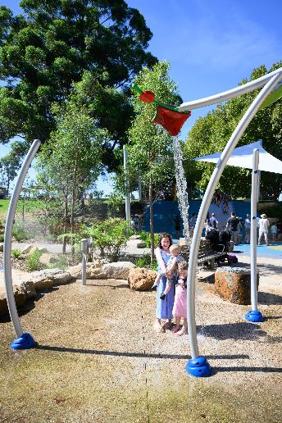

And cool off in the water play area.

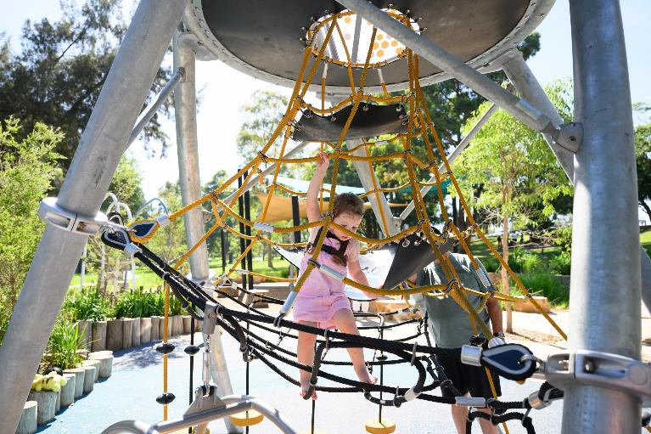

I can climb to the top of the tube slide.

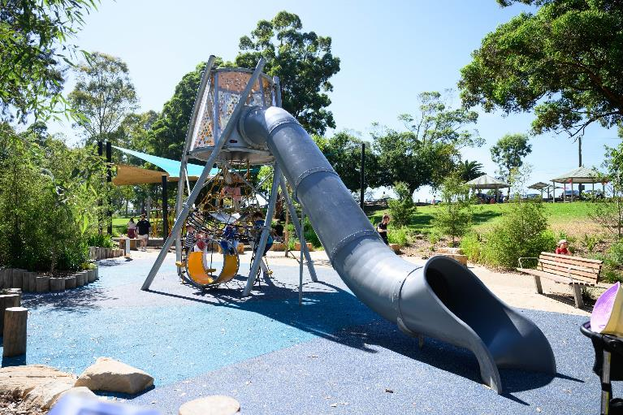

And slide down the tube slide.

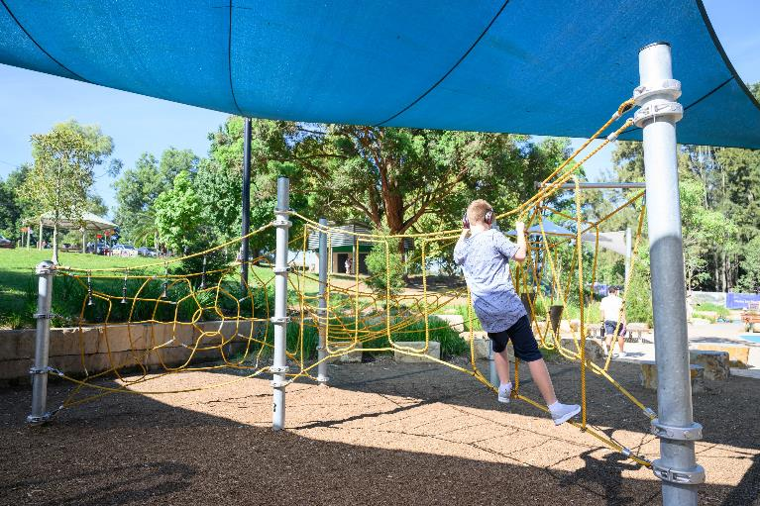

I can try the large rope climbing equipment.

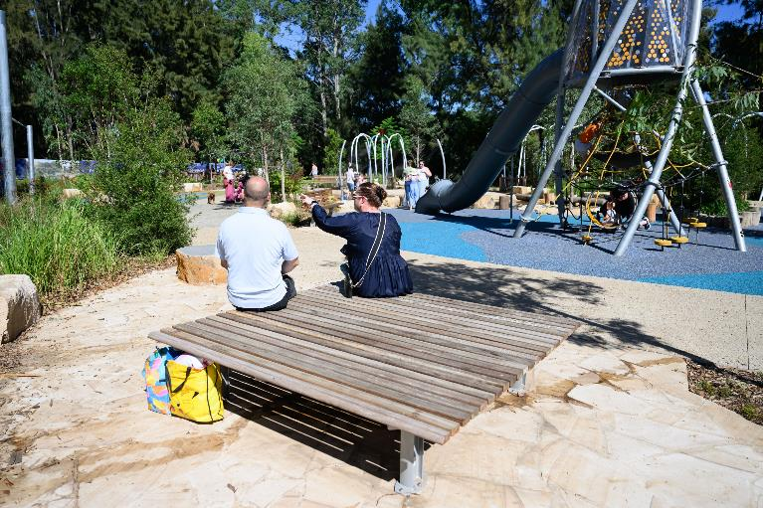

There are more seating areas where I can rest.

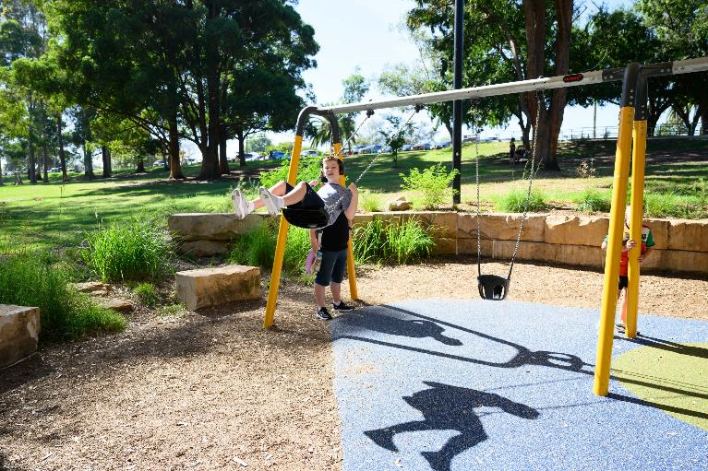

I can play on the swings.

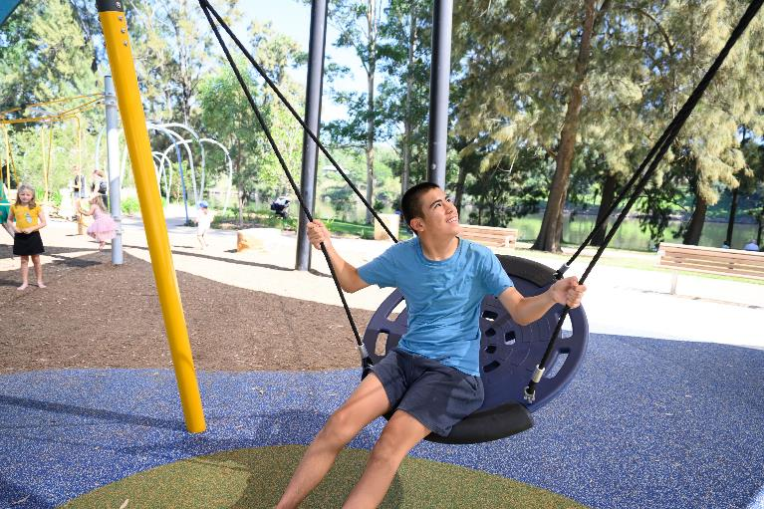

And I can try my turn at the swing basket.

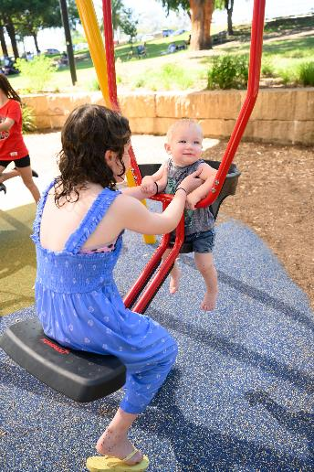

There is a joey swing chair we can try together.

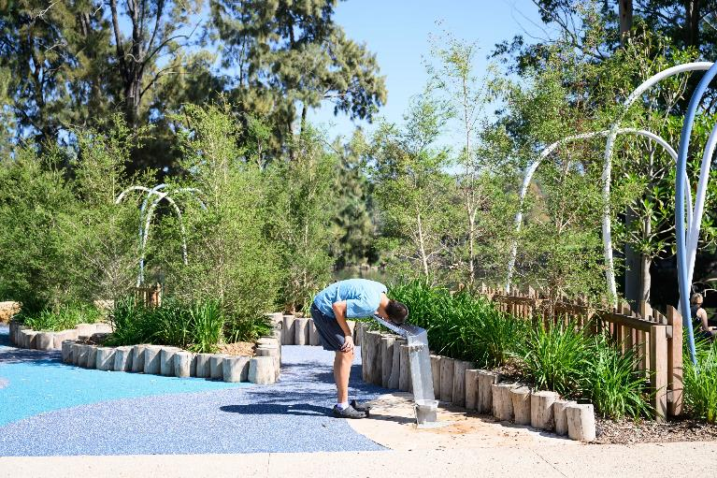

I can have a drink from the water bubbler.

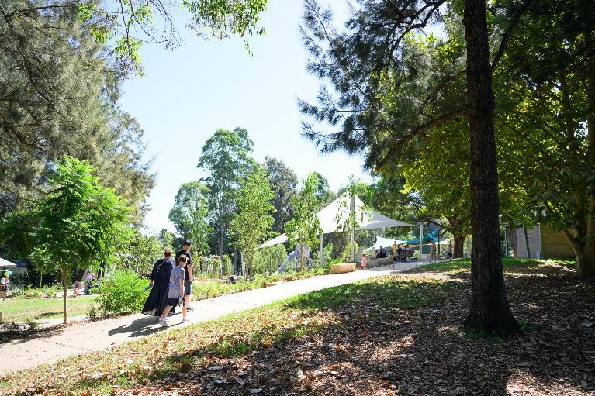

After a long day, I head home.

Thank you for visiting
Tench Reserve

penrith.city
penrith.city

